**Wrapper Class**

* The wrapper class provides the mechanism to convert primitive into object and object into primitive.

|  |  |
| --- | --- |
| **Primitive Type** | **Wrapper Class** |
| byte | Byte |
| short | Short |
| int | Int |
| long | Long |
| float | Float |
| double | Double |
| char | Char |
| boolean | Boolean |

**Autoboxing**

* Conversion of primitive data type into its corresponding wrapper class/object type is known as autoboxing.

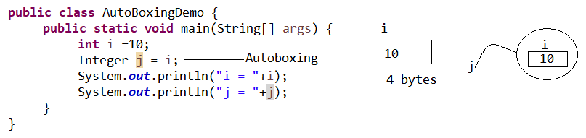

**Unboxing**

* Conversion of wrapper class/ object type into its corresponding primitive type is known as unboxing.

